INTERNSHIP REPORT
On
BEAST OS
A Cross-Platform EdTech Operating System for ICSE Board Preparation
Submitted To
School of Computer Science and Engineering
IILM University, Greater Noida, U.P.
In partial fulfilment of the requirement for the award of the degree of
B.Tech CSE


By
Roll Number of Student:CS-2341591
Name of Student: ALOK KUMAR
Batch: 2023-27

CANDIDATE'S DECLARATION
I, Alok Kumar, do hereby declare that the internship report titled “Beast OS – A Cross-Platform EdTech Operating System for ICSE Board Preparation” has been completed by me to fulfil the requirement for the award of the degree of Bachelor of Technology in Computer Science and Engineering. All the references have been quoted and I have not taken as such any material from any other source. I affirm that this report is my own work and has not been submitted to any other institute for any degree/diploma requirement, and I shall be solely responsible for any kind of copyright violation in this regard.
Signature: ______________________
Student Name: Alok Kumar
Roll No.: CS-2341591
Date: 30/08/2026

ACKNOWLEDGEMENT
I am using this opportunity to express my gratitude to everyone who supported me throughout my internship at Beast Learners. I am thankful for their aspiring guidance, invaluable constructive criticism, and friendly advice during the course of this work. I am sincerely grateful to my mentors and the engineering team at Beast Learners for sharing their truthful and illuminating views on the many technical issues I encountered while building the Beast OS platform.
I would like to thank my internship supervisor and the Beastlearners engineering team for the opportunity to work on a live, production-grade product, and for their continuous guidance on system design, code quality, and security best practices.
I would also like to express my sincere gratitude to the Department of Computer Science and Engineering, IILM University, Greater Noida, for facilitating this internship and for their academic support throughout the programme.
Finally, I express my heartfelt gratitude to my parents and friends for their constant encouragement and blessings.
Signature: ______________________
Student Name: Alok Kumar
Roll No.: CS-2341591

INTERNSHIP COMPLETION CERTIFICATE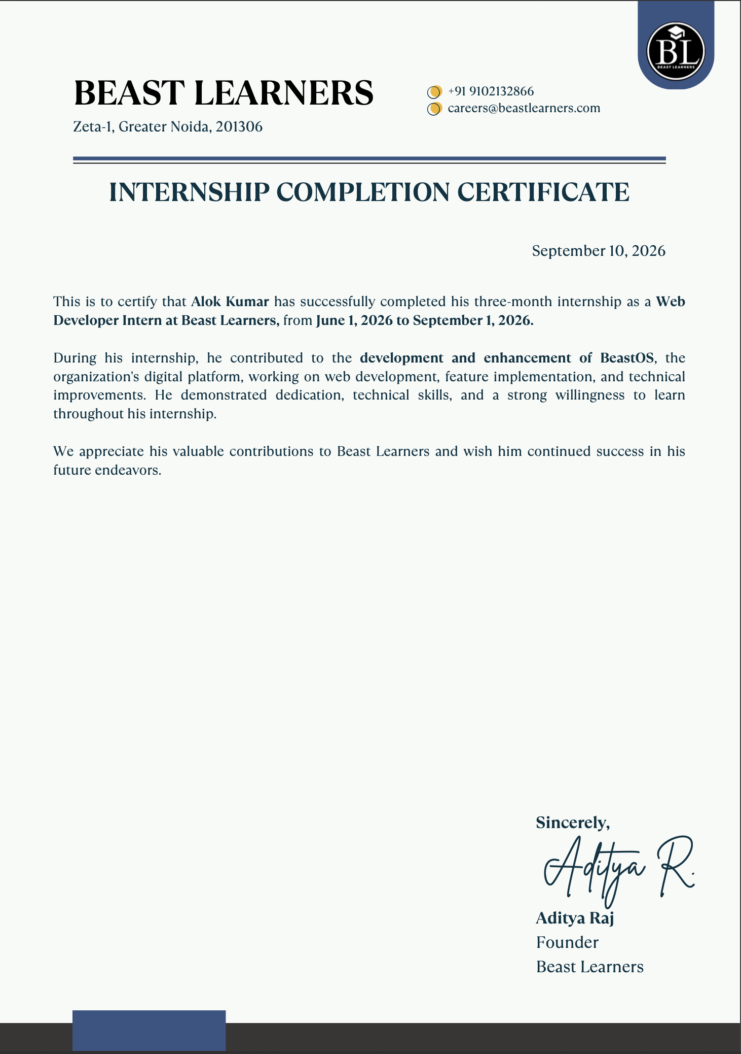

TABLE OF CONTENTS
Candidate's Declaration i
Acknowledgement ii
Internship Completion Certificate iii
Table of Contents iv
4. Project Description 1
4.1 Introduction 1
4.2 Organization Profile 1
4.3 Problem Statement 2
4.4 Project Objectives 2
4.5 Scope of the Project 3
4.6 Technologies and Tools Used 3
4.7 System Architecture 4
4.8 Methodology 5
4.9 Expected Outcomes 7
4.10 Certificates of Completion and Communication Proof 8
5. Bibliography / References 10

4. PROJECT DESCRIPTION

4.1 Introduction
This report presents an account of the internship undertaken by Alok Kumar, a B.Tech Computer Science and Engineering student at IILM University, Greater Noida, U.P., at Beastlearners, an EdTech organisation building technology-driven solutions for school-level board examination preparation. The internship was carried out in the role of Full-Stack Developer Intern, with primary responsibility for engineering features across the web, mobile, and backend layers of the organisation's flagship product.
The project undertaken during the internship, Beast OS, is a cross-platform EdTech Operating System designed to revolutionise ICSE Class 9 and Class 10 board examination preparation. The platform transitions traditional, static learning into a dynamic, data-driven experience by integrating AI-assisted tutoring, real-time competitive assessments, and automated syllabus tracking into a single, unified product. Over the course of the internship, the intern was directly responsible for designing, building, and shipping four major product modules to production, working across the complete technology stack – from PostgreSQL database migrations and serverless Edge Functions to React-based web and React Native mobile interfaces.

4.2 Organization Profile
Beastlearners is an EdTech organisation focused on reimagining how school students prepare for board-level examinations. The organisation's core product, Beast OS, positions itself as an “operating system” for board exam preparation rather than a conventional content-delivery app – combining structured syllabus tracking, AI tutoring, and gamified, real-time competitive assessment into one platform. Beastlearners places strong emphasis on engineering rigor, data security, and product velocity, running an agile, feature-driven development process in which interns are given genuine ownership of production modules rather than isolated training exercises.
The organisation's engineering culture centres on a modern, decoupled technology stack that allows the web application, the mobile application, and the backend services to evolve independently while sharing a single source of truth for data – an architecture that gave the intern direct, hands-on exposure to real-world, production-grade software engineering practices.

4.3 Problem Statement
Traditional preparation for the ICSE Class 9 and Class 10 board examinations remains largely static and fragmented. Students typically rely on printed material, generic mobile applications, and disconnected practice tests that provide no continuous, real-time picture of syllabus readiness. Existing tools generally suffer from the following limitations:
- No unified, real-time view of a student's chapter-wise, subject-wise, and overall board-readiness.
- Lack of engaging, competitive assessment formats that motivate consistent daily practice.
- Rigid, one-size-fits-all subscription models that do not accommodate students who prefer one-time purchases over recurring payments.
- Content management workflows that require direct developer involvement for even minor textual or policy updates.
Beast OS was conceived to directly address these gaps by combining automated syllabus tracking, a real-time multiplayer quiz engine, a flexible monetisation layer, and a self-service content management system within a single, cross-platform product.

4.4 Project Objectives
- To design and implement a hybrid monetisation system supporting both recurring subscriptions and one-time payments through the Razorpay payment gateway.
- To build a headless Content Management System (CMS) enabling non-technical staff to publish and update rich-text pages across web and mobile without developer intervention.
- To engineer a hierarchical “Syllabus Command Centre” that automatically tracks and recalculates a student's board-readiness in real time as they complete learning activities.
- To develop a server-authoritative, real-time multiplayer quiz engine (“Beast Battle”) capable of supporting synchronised, competitive assessments with strict anti-cheat safeguards.
- To gain practical, production-level experience with full-stack development, cloud database design, serverless computing, real-time systems, and application security.

4.5 Scope of the Project
The scope of the internship project spanned the full product lifecycle of four modules within Beast OS – from database schema design through to deployment on both the web and mobile clients. The work covered backend logic (PostgreSQL schema migrations and Supabase Edge Functions), payment-gateway integration, real-time communication using WebSockets, front-end engineering in React.js and React Native, and application-security measures such as input sanitisation. The scope did not extend to infrastructure provisioning, DevOps/CI-CD pipeline ownership, or the design of the organisation's overall business strategy, which remained the responsibility of full-time engineering and product staff.

4.6 Technologies and Tools Used
Table 4.1 below summarises the primary technologies and tools used during the internship.
Table 4.1: Technology Stack Used in Beast OS
Layer | Technology / Tool | Purpose
Frontend (Web) | React.js (Vite), TailwindCSS | Responsive web application and admin panel UI
Mobile | React Native (Expo), NativeWind | Cross-platform iOS/Android application
Backend & Database | Supabase (PostgreSQL, Edge Functions, Realtime/WebSockets) | Data storage, serverless business logic, real-time communication
Payments | Razorpay API (Subscriptions & Orders) | Recurring and one-time payment processing
Security | DOMPurify, react-native-render-html | HTML sanitisation to prevent XSS vulnerabilities

4.7 System Architecture
Beast OS follows a decoupled, client-server architecture in which the React.js web application and the React Native mobile application act as independent presentation-layer clients that communicate with a shared Supabase backend over REST and WebSocket connections. This separation allows the web and mobile teams to iterate independently while guaranteeing a single, consistent source of truth for all student, content, and payment data.
The backend follows a zero-trust design philosophy: business-critical logic – such as payment verification, score calculation, and access control – is never trusted to the client. Instead, this logic is executed exclusively within Supabase Edge Functions running on the server, with Row-Level Security (RLS) policies enforced at the PostgreSQL layer to ensure that a client can only read or write data it is explicitly authorised to access. Real-time features, such as live multiplayer quiz states and dynamic readiness scores, are propagated to clients using Supabase's WebSocket-based Realtime channels, allowing the UI to update instantly in response to server-side state changes rather than relying on manual polling.
Figure 4.1: High-Level System Architecture of Beast OS
Layer | Component | Responsibility
Client | Web App (React.js) / Mobile App (React Native) | Presentation layer; renders UI and dispatches requests
Communication | REST APIs & Supabase Realtime (WebSockets) | Synchronous requests and live, bidirectional data sync
Server (Zero-Trust) | Supabase Edge Functions | Payment routing, score computation, webhook handling
Data | PostgreSQL (with Row-Level Security) | Persistent storage with policy-enforced access control
Third-Party | Razorpay API | Subscription and one-time order processing

4.8 Methodology
The internship followed an agile, module-driven methodology in which each feature was scoped, designed, developed, tested, and shipped iteratively. The intern was responsible for engineering four major modules of Beast OS, described below, followed by an account of the key technical challenges encountered and the solutions implemented.
4.8.1 Hybrid Monetisation Store
- Upgraded the platform from a purely recurring subscription model to a hybrid model supporting both recurring and one-time payments.
- Handled complex database migrations in PostgreSQL to support the new plan structures without disrupting existing subscribers.
- Built dynamic Edge Functions that route each user to either the Razorpay Subscriptions API or the Orders API depending on the plan selected.
- Implemented automated webhook handlers that dynamically calculate subscription expiration dates upon successful payment.
4.8.2 Headless CMS (Dynamic Page Management)
- Built a fully dynamic Content Management System within the Admin Panel to create, edit, and publish rich-text pages such as the Privacy Policy and Terms of Service.
- Integrated the TipTap WYSIWYG editor and implemented image-upload handling to Supabase storage.
- Implemented strict HTML sanitisation using DOMPurify on the web client and react-native-render-html on the mobile client to prevent Cross-Site Scripting (XSS) vulnerabilities.
- Engineered a dynamic footer component that automatically updates across both the web and mobile applications via Over-The-Air (OTA) updates, without requiring an app-store release.
4.8.3 Syllabus Command Centre
- Built a five-level hierarchical drill-down interface (Overall → Subject → Chapter → Details → Action) designed to prevent cognitive overload for students navigating a large syllabus.
- Implemented a “Zero-Touch Automation” architecture in which routine student actions – such as taking quizzes or using the AI tutor – automatically trigger background database updates without any manual data entry.
- Engineered real-time “ripple-effect” recalculation, where completing a single task automatically updates chapter readiness, subject readiness, and overall board-readiness scores.
4.8.4 Beast Battle – Real-Time Multiplayer Engine
- Built a synchronised, competitive multiplayer quiz engine enabling students to compete against one another in real time.
- Engineered a server-authoritative state machine using Supabase Realtime (WebSockets) to manage lobbies, live countdowns, and game-state transitions.
- Implemented strict anti-cheat mechanisms, including client-side randomisation of question and option order and an unbreakable, server-enforced timer.
- Developed a backend scoring algorithm using Edge Functions that mathematically prioritises accuracy (100 base points) over speed (a maximum of 25 bonus points).
- Built a “Rematch/Revenge” viral loop that instantly clones the settings of a completed game into a fresh lobby, encouraging repeat engagement.
4.8.5 Challenges Faced and Solutions Implemented
Table 4.2: Key Technical Challenges and Solutions
Challenge | Solution Implemented
Maintaining consistent, low-latency game state across many concurrent WebSocket connections during Beast Battle matches. | Adopted a server-authoritative state machine over Supabase Realtime, so all clients render a state broadcast by the server rather than computing state locally, eliminating drift between players.
Preventing score manipulation and question leakage in a client-rendered quiz engine. | Moved all scoring logic into server-side Edge Functions and combined this with client-side randomisation of question/option order plus a server-enforced timer, so no score-relevant computation is ever trusted to the client.
Keeping readiness scores (chapter, subject, overall) consistent as students complete activities from multiple entry points (quizzes, AI tutor, manual updates). | Designed a “Zero-Touch Automation” pipeline where every qualifying student action triggers a common backend recalculation routine, ensuring a single source of truth instead of scattered client-side calculations.
Achieving visual and behavioural consistency between the React.js web app and the React Native mobile app while using different rendering engines for rich-text content. | Standardised on a shared design language (TailwindCSS on web, NativeWind on mobile) and used platform-appropriate sanitisation libraries (DOMPurify vs. react-native-render-html) so the same CMS-authored content renders safely and consistently on both platforms.
Supporting two structurally different payment flows (recurring vs. one-time) without duplicating business logic. | Built a single dynamic Edge Function that inspects the selected plan type at request time and routes to the appropriate Razorpay API (Subscriptions or Orders), keeping payment logic centralised and maintainable.

4.9 Expected Outcomes
The internship resulted in four production-grade modules being shipped as part of Beast OS, each directly addressing a defined product objective. The hybrid monetisation store enabled the organisation to serve both subscription-oriented and one-time-purchase customer segments; the headless CMS reduced dependency on engineering resources for routine content and policy updates; the Syllabus Command Centre gave students a real-time, granular view of board-exam readiness; and the Beast Battle engine introduced a secure, engaging, real-time competitive assessment format to the platform.
On a personal level, the internship provided substantial hands-on experience with full-stack, cross-platform development, cloud-native backend design using PostgreSQL and serverless Edge Functions, real-time systems built on WebSockets, third-party payment-gateway integration, and secure coding practices such as input sanitisation and server-authoritative logic. These outcomes align closely with industry expectations for a Full-Stack Developer role and have significantly strengthened the intern's readiness for professional software engineering work.
As future scope, the Syllabus Command Centre could be extended with predictive analytics to forecast a student's likely board-exam performance, the Beast Battle engine could be scaled to support larger tournament-style formats, and the CMS could be extended to support localisation for multiple languages and additional examination boards beyond ICSE.

4.10 Certificates of Completion and Communication Proof
The Internship Completion Certificate issued by Beastlearners is attached in the front matter of this report (see “Internship Completion Certificate”). Copies of relevant e-mail communication and other proof of engagement with the organisation during the internship period are appended below.
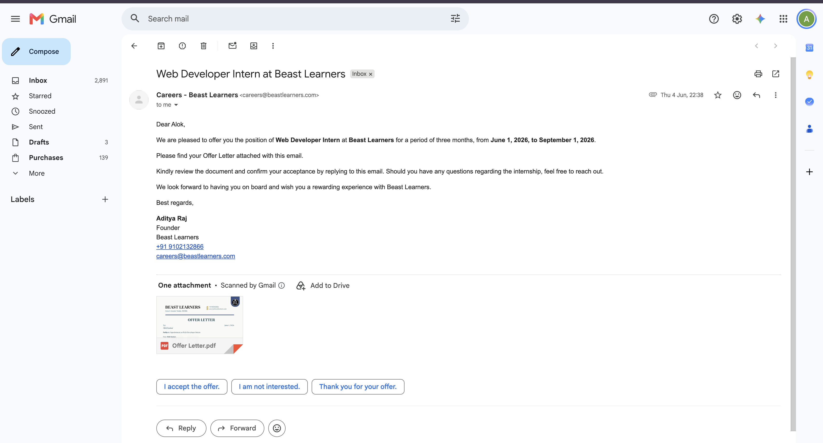
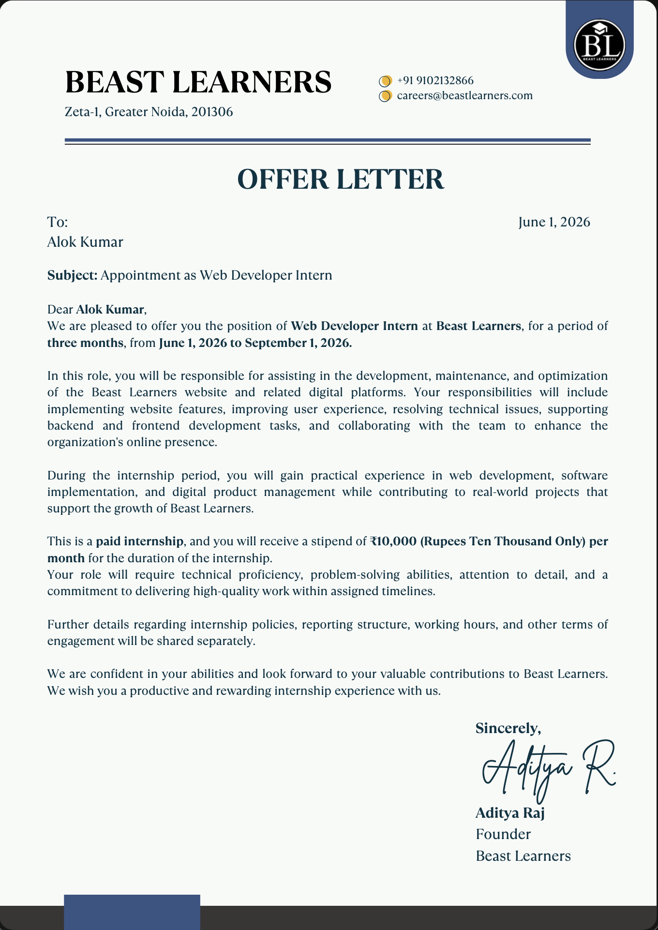

5. BIBLIOGRAPHY / REFERENCES
[1] React – A JavaScript library for building user interfaces. Available at: https://react.dev
[2] Vite – Next Generation Frontend Tooling. Available at: https://vitejs.dev
[3] Tailwind CSS Documentation. Available at: https://tailwindcss.com/docs
[4] React Native Documentation. Available at: https://reactnative.dev/docs/getting-started
[5] Expo Documentation. Available at: https://docs.expo.dev
[6] Supabase Documentation – Database, Edge Functions and Realtime. Available at: https://supabase.com/docs
[7] PostgreSQL 16 Documentation. Available at: https://www.postgresql.org/docs/
[8] Razorpay API Reference – Subscriptions and Orders. Available at: https://razorpay.com/docs/api/
[9] DOMPurify – DOM-only, super-fast, uber-tolerant XSS sanitizer. Available at: https://github.com/cure53/DOMPurify
[10] TipTap Editor Documentation. Available at: https://tiptap.dev/docs
[11] OWASP Foundation – Cross-Site Scripting (XSS) Prevention Cheat Sheet. Available at: https://owasp.org

